Accelerating Acoustic Agglomeration Predictions:
A Physics-informed Neural Network
with Fourier Featuring
for Sound Pressure Gradient and Stokes Drag
Hang Yin^{1,2}, Pengzhan Liu^{1,2,3}, Bing Feng Ng^{1*}
¹School of Mechanical and Aerospace Engineering, Nanyang Technological University, Singapore 639798
²Energy Research Institute @ NTU, Nanyang Technological University,
Singapore 639141
³School of Advanced Manufacturing Engineering, Nanjing University,
Suzhou 215163, China
*Corresponding author’s email address: bingfeng@ntu.edu.sg

Highlights
- PINN for large scale sound induced particle motion prediction.
- Separate training and integration for modelling efficiency.
- PINN prediction results highly align with FEM simulation.
- Particle motion and collision behaviours are predicted accurately by FF-PINN.
- Simulation by FF-PINN model is much faster than FEM.

Abstract
Conventional simulation approaches face difficulties for massive particle motion and efficient methods are urgently in need. A Fourier-featured physics informed neural network (FF-PINN) framework is developed for efficient particle resolved simulation of acoustic agglomeration (AA). The method replaces repeated evaluation of the sound pressure gradient force (SPGF) and Stokes drag with pretrained neural surrogates constructed from governing equations. The acoustics force field is decomposed into spatial and temporal components and learned through dedicated subnetworks with Fourier feature encoding, while a separate network captures the velocity dependent drag contribution. Validation against finite element method (FEM) and discrete element method (DEM) shows that the predicted particle concentration fields agree closely with reference solutions, with relative errors below 6%. The proposed approach reduces computational time by 71.4% and 95.5% compared to DEM for 1,000,000 particles and FEM simulations for $100,000$ particles, respectively. Using the accelerated framework, systematic parametric studies are conducted over sound pressure level (SPL), excitation frequency, particle density and diameter. The results reinforce that particle transport and aggregation are governed by the coupling between acoustic forcing, flow field and particle inertia, leading to frequency- and density-dependent attenuation of particle displacement. This coupling also enhances collision probability for particles with larger size disparity and increased SPL. This work demonstrated FF-PINN to be an efficient approach for AA simulation that significantly reduces computational cost while maintaining adequate prediction accuracy.

Keywords: Acoustic agglomeration, Fourier-Featured Physics-Informed Neural Network, simulation, concentration, collision

Introduction
Particulate matter (PM) is a major hazard to human health, necessitating effective removal strategies [1]. In particular, fine particles such as PM2.5 are difficult to capture using conventional filtration methods due to their small size. To address this limitation, pre-conditioning techniques that enhance particle size prior to removal have been explored. Among them, acoustic agglomeration (AA) has attracted increasing attention in applications such as flue gas treatment, diesel exhaust systems and ambient air filtration [2], [3], [4], [5], as it promotes particle coagulation and facilitates subsequent removal [6].
AA describes the process of particle interaction, collision and agglomeration under acoustic excitation, where sound waves transfer mechanical energy to suspended particles [6], [7]. In standing wave fields, particles normally tend to migrate toward pressure nodes, where oscillatory fluid motion induces relative movement between particles and the carrier medium, giving rise to Stokes drag [8], [9]. This acoustic motion enhances collision probability and leads to the formation of larger aggregates. As the process continues, particles accumulate in nodal regions, forming clusters that are more readily removed. Compared with conventional removal approaches, AA offers advantages such as scalability, relatively low energy consumption and improved efficiency in capturing fine particles by enhancing agglomeration prior to downstream separation [10], [11].
The performance of AA during an experiment depends on a variety of key parameters, which collectively govern the net agglomeration outcome by modulating the underlying physical mechanisms. Acoustically, sound intensity provides the energy for particle motion [12], [13], frequency determines the effectiveness of particle entrainment relative to inertia [14], [15], [5], [6] and wave patterns define the spatial force field [9], [16]. For particles, their type influences collision and cohesion dynamics [5], [3], [12], size distribution drives relative motion via orthokinetic interaction [17], [18] and number concentration sets the baseline collision probability [19], [15], [18]. Regarding the fluid medium, temperature affects both viscosity and potential condensation [11], thereby modifying viscous drag [20], [21] and interparticle binding. The interplay of these factors nonlinearly influences primary forces like the Sound pressure gradient force (SPGF) and Stokes drag, as well as secondary mechanisms such as acoustic wake effects and mutual radiation pressure effects, ultimately determining agglomeration efficiency.

Given the complexity and sensitivity of various parameters described above, researchers commonly rely on numerical simulations before physical trials. Several numerical paradigms are available and widely used in AA research, each with its own assumptions, strengths and limitations. The discrete element method (DEM) treats individual particles as explicit entities subject to pressure-gradient, hydrodynamic and body forces [22], [23]. DEM can represent collision resolution, rolling/sliding friction and detailed trajectories, which makes it well suited for studies where particle-level interactions are critical. However, DEM’s fidelity comes at a steep computational cost. Resolving large numbers of particles with small timesteps and evaluating detailed force models often becomes prohibitively expensive, especially when acoustic forcing and coupled flow fields must be updated at acoustic timescales.
On the other hand, the finite element method (FEM) provides a continuum-based framework in which the governing acoustic and flow equations are discretized over the computational domain and solved through mesh-based numerical approximation [25]. This approach is particularly effective for resolving coupled fields such as acoustic pressure, fluid velocity and particle transport with high spatial fidelity. Nevertheless, achieving such fidelity typically requires fine spatial meshes and small temporal increments, which can lead to substantial computational overhead and memory consumption, especially for high-frequency acoustic excitation and long transient simulations [26].
As traditional numerical methods trade computation time for physical detail, an innovative alternative is to incorporate machine learning into the simulation pipeline to accelerate the most expensive components while retaining the physical structure of the remaining model. Physics-informed Neural Networks (PINNs) provide a framework to train models with physics governing equations. Instead of computing certain quantities by direct numerical solution at every timestep, a neural model is trained to approximate the mapping from relevant inputs to the target quantity. Once trained, PINN produces that quantity via a single forward evaluation, which is orders of magnitude cheaper than repeated per-particle analytical/numerical solvers through complicated calculations and massive degrees of freedom.
In this paper, the Fourier-featured PINN architecture (FF-PINN) is introduced for the prediction of particle motion and collision under SPGF and Stokes force where local acoustic pressure gradients is coupled to flow oscillations. FF-PINN preserves physical interpretability while achieving substantial speedups in high spatial or temporal resolution simulations. As shown in Fig. 1, the following sections of this paper documents the specific FF-PINN architecture, training procedures, validations against FEM/DEM data and present initial parametric studies. By applying FF-PINN framework for the training of elements decomposed from complicated dynamics equations, significant improvements to simulation efficiency can be obtained while maintaining prediction accuracy.
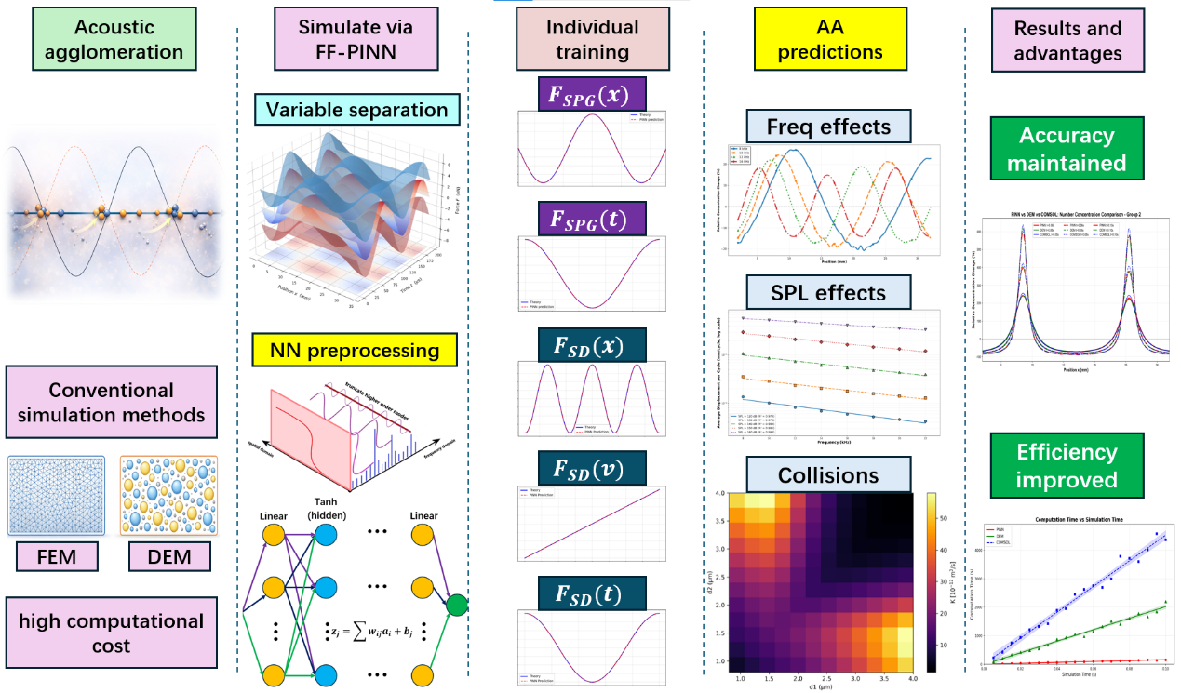
Figure 1. Schematic overview of the proposed FF-PINN framework for AA simulation. The AA dynamics originally solved by FEM and DEM are decomposed into separate force components, which are independently trained through dedicated FF-PINNs with Fourier featured preprocessing. The trained models are then combined for rapid prediction of particle transport, frequency and SPL effects and collision behavior. The framework maintains FEM level accuracy while achieving substantial improvement in computational efficiency.

Methodology

2.1 Fundamental sound wave equation
Under a standing wave condition, the displacement of sound waves propagating in one-dimension can be expressed as a function with respect to position and time [10]
$\begin{aligned}χ\left(x,t\right)=-Acos\left(kx\right)sin\left(ωt\right)\#\left(1\right)\end{aligned}$where χ is the displacement of the fluid molecules under sound waves, x is the coordinate, A is the displacement amplitude, k is the wave number, ω is the angular frequency and t is the time.
The displacement amplitude and wave number are defined as
$$\begin{aligned}A=\frac{p_{0}}{ρcω}\#\left(2\right)\end{aligned}$$
$$\begin{aligned}k=\frac{2π}{λ}\#\left(3\right)\end{aligned}$$
where p₀ is the modulus sound pressure, ρ is the medium density, c is the sound speed and λ is the wavelength. The oscillatory fluid velocity induced by the standing wave is expressed as
$$\begin{aligned}v\left(x,t\right)=-ωAcos\left(kx\right)cos\left(ωt\right)\#\left(4\right)\end{aligned}$$
Accordingly, the acoustic pressure field at an arbitrary position and time is written as
$\begin{aligned}p\left(x,t\right)=kγp_{0}A\sin\left(kx\right)sin\left(ωt\right)\#\left(5\right)\end{aligned}$where γ is the adiabatic index.

2.2 Particle dynamic representation
For suspended spherical particles with radius r_{p} the dominant driving force in the standing-wave field originates from the alternating acoustic pressure gradient. The resulting pressure-gradient force is formulated as
$$\begin{aligned}F_{PG}\left(x,t\right)=C_{a}Φ_{x}\left(x\right)Φ_{t}(t)\#\left(6\right)\end{aligned}$$
where
$$\begin{aligned}C_{a}=2πk^{2}γp_{0}Ar_{p}^{3}\#\left(7\right)\end{aligned}$$
is the acoustic force coefficient and the separable basis functions are given by
$$\begin{aligned}Φ_{x}\left(x\right)=\sin\left(kx\right), Φ_{t}\left(t\right)=\sin\left(ωt\right)\#\left(8\right)\end{aligned}$$
The Stokes drag acting on the particle is expressed as
$$\begin{aligned}F_{D}\left(x,t\right)=-C_{d}\left(v\left(x,t\right)-V_{p}\left(t\right)\right)\#(9)\end{aligned}$$
with
$$\begin{aligned}C_{d}=6πμr_{p}\#\left(10\right)\end{aligned}$$
where μ is the dynamic viscosity of the fluid medium and $V_{p}$ is the particle velocity. For simplicity, local fluid velocity is ignored. The particle motion is then governed by the force-balance equation
$$\begin{aligned}m_{p}​\frac{dVp}{dt} ​​=F_{PG​}+F_{D​}\#\left(11\right)\end{aligned}$$

2.3 Reference numerical solvers for AA simulation
Before introducing the FF-PINN framework, two reference numerical solvers were employed to establish baseline particle transport behavior in the acoustic field, namely the discrete element method and the finite element method. For DEM, each particle is explicitly tracked in a Lagrangian framework. The particle motion follows the same governing force balance introduced in Section 2.2. At every timestep, the sound pressure gradient force and the Stokes drag are directly evaluated from the instantaneous particle position and velocity. The governing equation is written in the standard form of dynamics same as Eq. (11). DEM serves as the most direct particle resolved implementation of the physical model, since the force acting on every particle is individually updated and integrated over time. This explicit treatment provides highly reliable particle trajectory and collision statistics, but the computational cost increases rapidly with particle numbers.
For the FEM, the same force formulation is preserved, while the surrounding air domain is discretized into many finite cells. The local acoustic force field inside each cell is represented through element shape functions, such that the force acting on an arbitrary point within the cell is interpolated from neighboring nodal values as
$$\begin{aligned}F_{h}\left(x,t\right)=\sum_{j=1}^{n_{e}}{N_{j}\left(x\right)F_{j}\left(x,t\right)}\#\left(12\right)\end{aligned}$$
where $N_{j}\left(x\right)$ is the interpolation shape function, $F_{j}\left(x,t\right)$ is the nodal force value and $n_{e}$
is the number of nodes in each element. In this way, the SPGF and Stokes drag are first evaluated at the mesh nodes and then continuously transferred across adjacent cells through the interpolation basis. (To clarify, the term “mesh nodes” here represents the interpolation points located at the ends of the divided elements, which is irrelevant to the nodes for sound waves.) The particle located inside the air domain receives its local driving force from the corresponding cell-wise reconstructed field, after which its trajectory is advanced using the same force balance equation as that in DEM. In this work, the FEM simulations were carried out using COMSOL Multiphysics, where the acoustic pressure field and the resulting force distribution were resolved over the discretized air domain and used as the high fidelity baseline for subsequent validation. To ensure a fair comparison, the computational procedures for DEM, FEM, NN model training and forward timestep simulations were all conducted using the same computing hardware equipped with Intel CORE i7, RTX3050, and 16 GB RAM.

2.4 Fourier-featured physics-informed Neural Network
To train a precise model that describes the SPGF and Stokes drag under certain position and time, a multilayer processor (MLP) is built for preliminary testing. However, such structure cannot capture a model that aligns well with the original equation due to the periodical alternation under both spatial and time domain. To better exploit the intrinsic mathematical structure of the acoustic excitation, the pressure-gradient force is reformulated into a separable representation, where the spatial and temporal dependencies are independently learned by two subnetworks. For a training batch containing N sampled spatiotemporal points, the subnetworks correspondingly produce vectorized outputs
$$\begin{aligned}X_{θ}=\left[\begin{matrix}X_{θ}\left(x_{1}\right) \\ X_{θ}\left(x_{2}\right) \\ ⋮ \\ X_{θ}\left(x_{N}\right)\end{matrix}\right]∈R^{N×1}, T_{θ}=\left[\begin{matrix}T_{θ}\left(t_{1}\right) \\ T_{θ}\left(t_{2}\right) \\ ⋮ \\ T_{θ}\left(t_{N}\right)\end{matrix}\right]∈R^{N×1}, v=\left[\begin{matrix}v\left(x_{1},t_{1}\right) \\ \begin{matrix}v\left(x_{2},t_{2}\right) \\ \begin{matrix}⋮ \\ v\left(x_{N},t_{N}\right)\end{matrix}\end{matrix}\end{matrix}\right]∈R^{N×1}\#\left(13\right)\end{aligned}$$
corresponding to the spatial modal and temporal oscillation responses. The pressure-gradient force over the entire batch is then assembled as
$$\begin{aligned}F_{PG}=C_{a}\left[\begin{matrix}X_{θ}\left(x_{1}\right)T_{θ}\left(t_{1}\right) \\ X_{θ}\left(x_{2}\right)T_{θ}\left(t_{2}\right) \\ ⋮ \\ X_{θ}\left(x_{N}\right)T_{θ}\left(t_{N}\right)\end{matrix}\right]=C_{a}\left(X_{θ}⊙T_{θ}\right)\#\left(14\right)\end{aligned}$$
where ⊙ denotes the Hadamard product that represents element-wise multiplication between two matrices. By incorporating the drag contribution, the particle governing equation over the sampled batch becomes
$$\begin{aligned}m_{p}{\dot{V}}_{p}=C_{a}\left[\begin{matrix}X_{θ}\left(x_{1}\right)T_{θ}\left(t_{1}\right) \\ X_{θ}\left(x_{2}\right)T_{θ}\left(t_{2}\right) \\ ⋮ \\ X_{θ}\left(x_{N}\right)T_{θ}\left(t_{N}\right)\end{matrix}\right]-C_{d}\left[\begin{matrix}v\left(x_{1},t_{1}\right)-V_{p}(t_{1}) \\ \begin{matrix}v\left(x_{2},t_{2}\right)-V_{p}(t_{2}) \\ \begin{matrix}⋮ \\ v\left(x_{N},t_{N}\right)-V_{p}(t_{N})\end{matrix}\end{matrix}\end{matrix}\right]\#\left(15\right)\end{aligned}$$
where
$$\begin{aligned}V_{p}∈R^{N×1}\#\left(16\right)\end{aligned}$$
represent the particle and fluid velocities evaluated at all sampled collocation points. To enforce the governing particle dynamics during training, the residual vector is defined as
$$\begin{aligned}R_{θ}=\left[\begin{matrix}R_{θ}^{\left(1\right)} \\ R_{θ}^{\left(2\right)} \\ ⋮ \\ R_{θ}^{\left(N\right)}\end{matrix}\right]=m_{p}{\dot{V}}_{p}-C_{a}X_{θ}⊙T_{θ}+C_{d}\left(v\left(x,t\right)-V_{p}\left(t\right)\right)\#\left(17\right)\end{aligned}$$
The residual vector is minimized over all collocation points during optimization during training, enabling simultaneous learning of the spatial and temporal force components while preserving the physical consistency of the particle motion. This batched separable formulation substantially reduces the complexity of the learning task, improves convergence stability and fully leverages the parallel computing capability of the NN framework.

2.5 Loss function and training strategy
To train the proposed separable PINN, the optimization objective is constructed by minimizing the governing residual. Based on the residual vector defined in Eq. (16), the physics-constrained loss is formulated as
$$\begin{aligned}L_{phy}=\frac{1}{N}\sum_{i=1}^{N}{{\left(R_{θ}^{\left(i\right)}\right)}^{2}}=\frac{1}{N}R_{θ}^{T}R_{θ}\#\left(18\right)\end{aligned}$$
The spatial component network employs sophisticated architecture designed to capture the periodic nature of the acoustic field. To demonstrate this, Fourier feature embedding is introduced into the temporal branch to improve the representation of oscillatory acoustic responses, following the recent advancements in PINNs for multi-frequency nonlinear dynamics [24]. The network first utilizes Fourier feature encoding as a critical enhancement mechanism, where the input spatial coordinate x is transformed through multiple frequency components before entering the main NN, during which components with wave numbers above 32 were truncated for systematic loss reduction, shown in Fig 2(a). Specifically, the Fourier features are generated for multiple wave numbers k corresponding to various operating frequencies, which can be expressed as
$$\begin{aligned}Φ\left(t\right)=f_{θ}\left(T\left(t\right)\right)=\left[\sin\left(ω_{1}t\right) \cos\left(ω_{1}t\right) … \sin\left(ω_{k}t\right) \cos\left(ω_{k}t\right)\right]∈R^{N×2k}\#\left(19\right)\end{aligned}$$
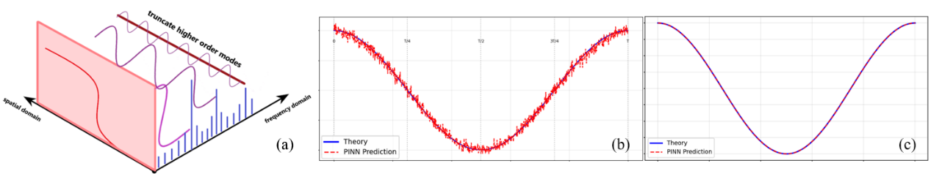
Figure 2. (a) Illustration of Fourier featuring. The original function is transferred into multiple modes on the frequency domain, where a preliminary frequency is given for the model fitting and higher frequency modes are truncated for noise reduction. (b) An example of model fitting without Fourier featuring results in severe noise after training. (c) Model fitting with Fourier featuring aligns smoothly with theoretical trend.
A comparison of the effect on whether Fourier featuring is used is demonstrated in Fig 2(b) and 2(c). The results after training with Fourier featuring align smoothly with the theoretical values, while the model appeared much noise and deviations without it.
The Fourier feature encoding provides the network with explicit knowledge of the acoustic wavelength, enabling better representation of periodic functions. This significantly accelerates convergence by providing the network with the correct frequency basis for the problem domain and reduces systematic loss. Training data generation employs a comprehensive sampling strategy covering one complete wavelength with $20,000$ data points randomly distributed across the spatial domain. The training process utilizes the analytical pressure gradient formula at t = 0 to generate ground truth labels, ensuring that the spatial network learns the correct pressure distribution pattern.
The temporal component network focuses exclusively on learning the time-dependent oscillation factor. The network accepts normalized time inputs t_{norm}∈ [0,1] and internally maps these to physical time through multiplication by the acoustic period. The temporal network architecture is the same as that of spatial network. The network explicitly preserves the physical frequency through a registered buffer, preventing frequency drift during training and ensuring that the learned temporal behavior matches the analytical function. Training employs a single-period sampling strategy with 20,000 data points distributed across one complete acoustic cycle. The network learns to reproduce the temporal oscillation pattern with high fidelity, targeting a convergence threshold of 1 × 10⁻⁸ to ensure accurate temporal representation. The prediction of SPGF with respect to spatial and time variation is shown in Fig 3.
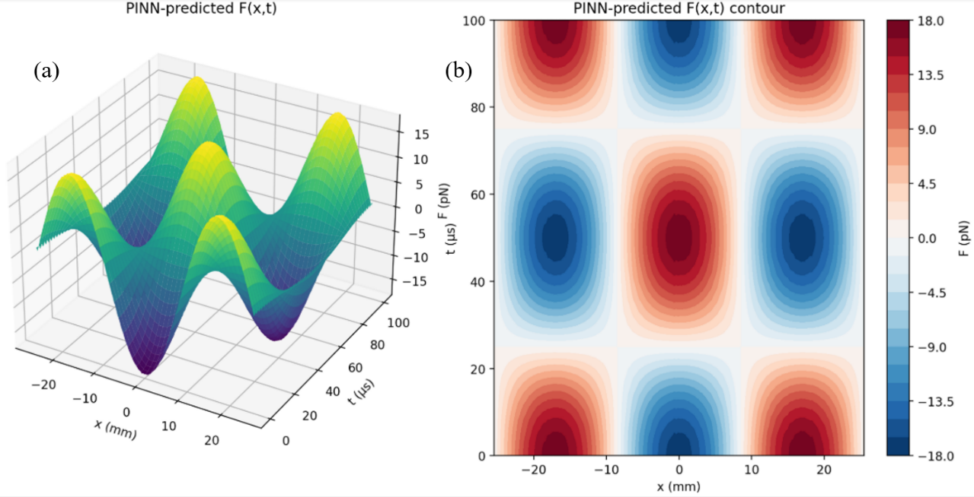
Figure 3. (a) 3D surface plot and (b) Contour plot for SPGF field under temporal and spatial variation, predicted by FF-PINN
The Fourier feature layer addresses NNs’ difficulty in learning high-frequency patterns by transforming raw input coordinates via sinusoidal basis functions into a representation space enriched with explicit frequency information. The training process employs several optimization strategies to ensure robust convergence. Adaptive learning rate scheduling with plateau detection reduces the learning rate by a factor of 0.5 when loss of plateaus, preventing oscillation around local minima. The Adam optimizer with a learning rate of 5 × 10⁻⁴ provides stable gradient updates, while the comprehensive data sampling ensures adequate coverage of the problem domain.
The velocity component network adopts a compact multilayer perceptron to learn the velocity-dependent part of the Stokes drag, mapping a single scaled input velocity to a normalized x-direction force. Specifically, $20,000$ samples of v are drawn uniformly from [-0.1, 0.1] m/s and linearly scaled to [0,1]$.$ The theoretical target is the velocity factor itself, which is then standardized using its dataset mean and standard deviation to form the regression target. The model is a sequential MLP with Tanh activations, trained with mean squared error (MSE) using Adam and ReduceLROnPlateau scheduling until the loss falls below 1 × 10⁻⁸. After convergence, the network is evaluated on 50 test points spanning the same velocity range to compute relative error statistics and the predictions are validated accurate enough. The trained model for Stokes drag with respect to particle displacement, velocity and simulated time is represented by the three mesh plots below in Fig 4, where the constant values were arbitrarily selected within a rational scale for trend demonstration.
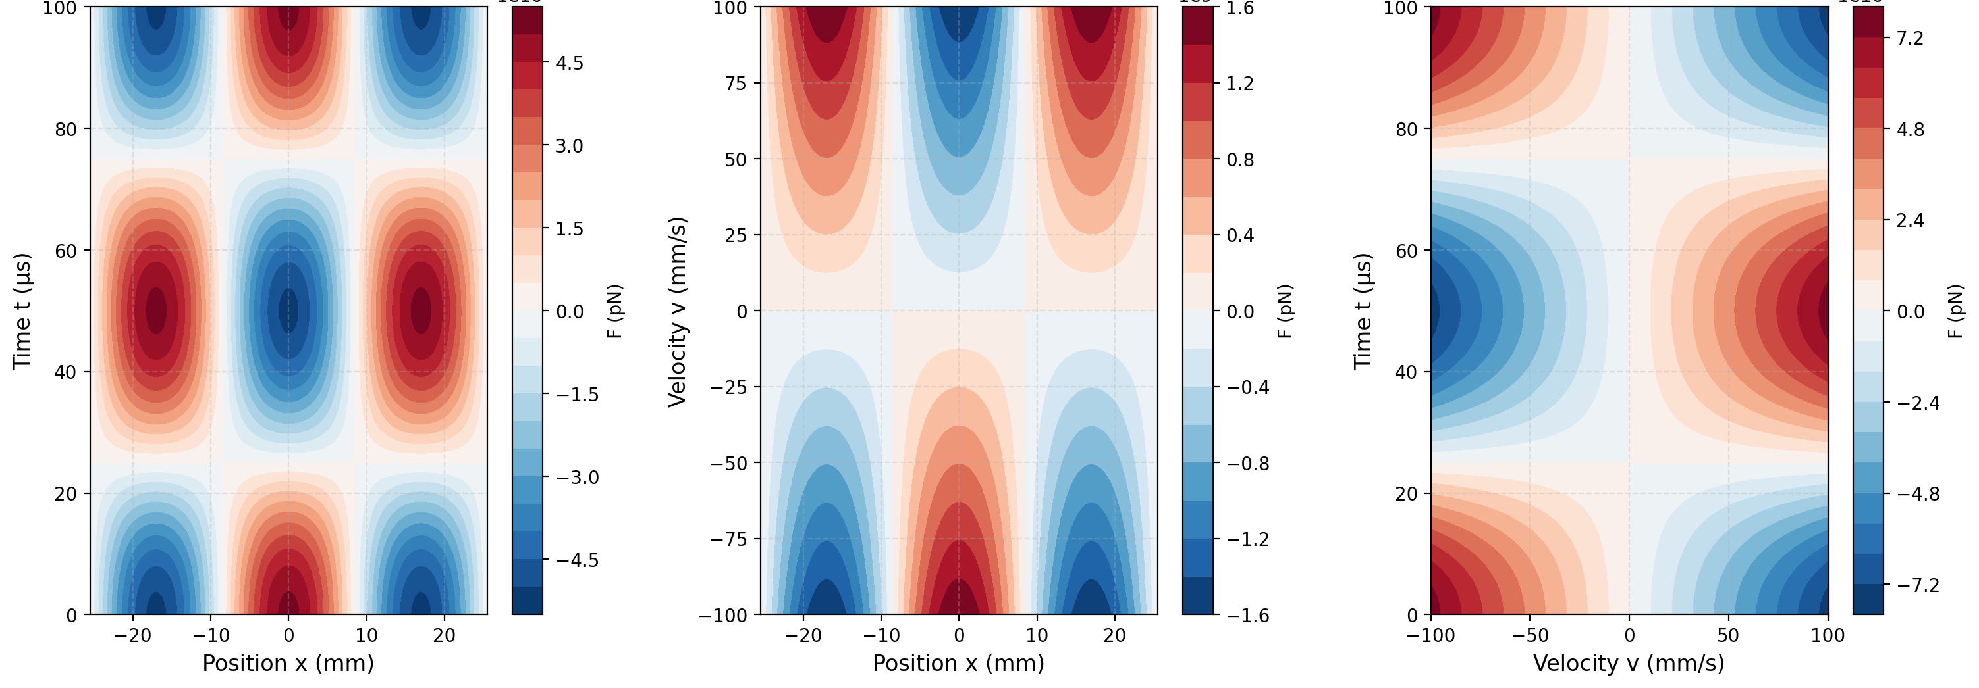
Figure 4. Contour plot for Stokes drags under arbitrary positions, velocities and time, predicted by FF-PINN
All networks implement comprehensive normalization strategies to ensure numerical stability and consistent scaling. The spatial network normalizes input coordinates to $[0,1]$ range and output forces to zero-mean unit-variance distributions. The temporal network similarly normalizes time inputs and temporal factors. A specialized Normalizer class handles the loading and application of normalization parameters, ensuring compatibility between training and inference phases.
The complete system integrates three networks through a multiplicative combination where the spatial and temporal components are reconstructed from their normalized representations and combined to produce the complete force. This modular approach enables independent training, validation and optimization of each component while maintaining the physical accuracy of the complete system. The loss function employs mean squared error (MSE) targeting a convergence threshold of 1 × 10⁻⁸ to ensure high accuracy. Owing to simplicity of the separated equations for independent training, the time consumption for training can be less than one minute, particularly with the aid of Fourier characterization for periodic feature capturing. The overall structure of the NNs is shown in Fig 5.
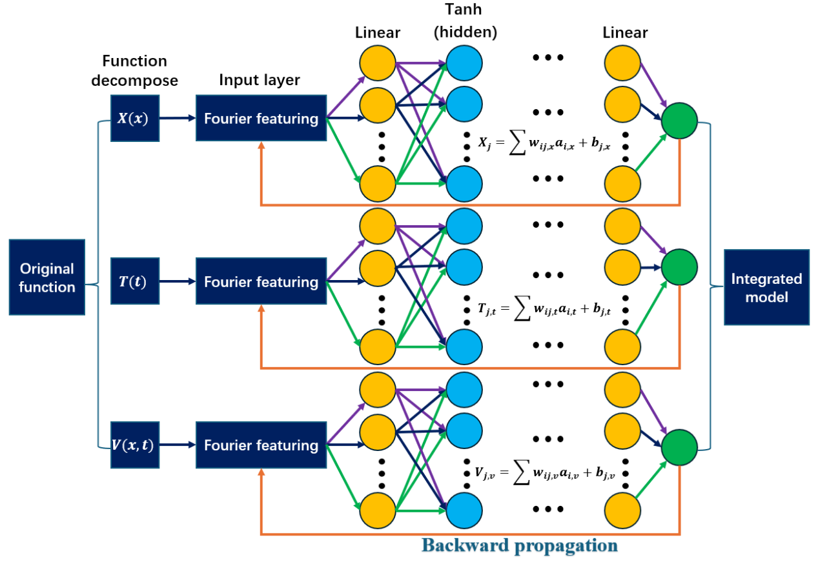
Figure 5. Schematic of the proposed FF-PINN framework with function decomposing, Fourier feature encoding, physics-informed loss feedback and integrated surrogate model construction.
The methodology demonstrates significant advantages over traditional approaches with computational efficiency through specialized networks, improved accuracy through Fourier feature encoding and physical consistency through explicit incorporation of acoustic wave parameters. The system achieves mean relative errors below 0.01% for every component of the overall dynamic equation, shown in Fig 6.
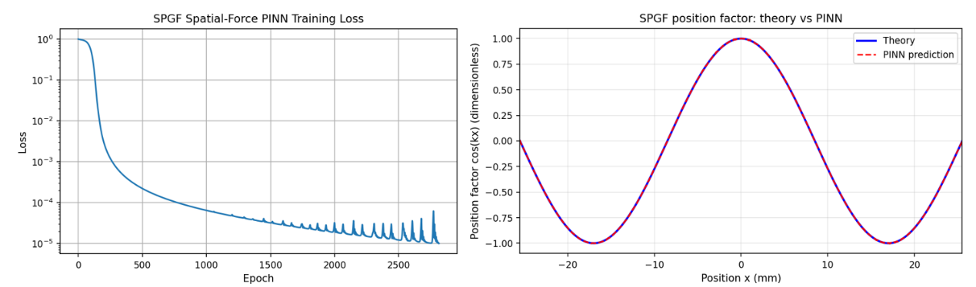
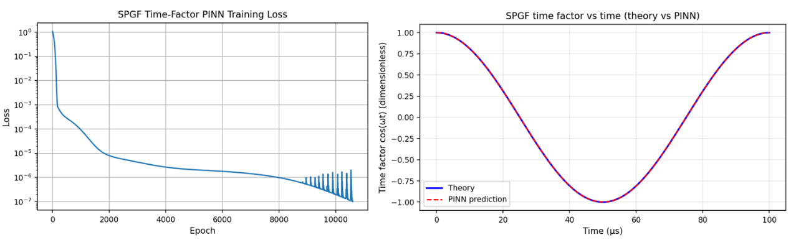
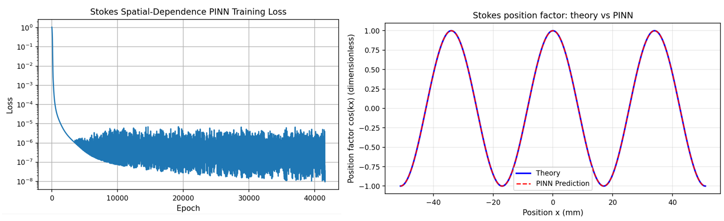
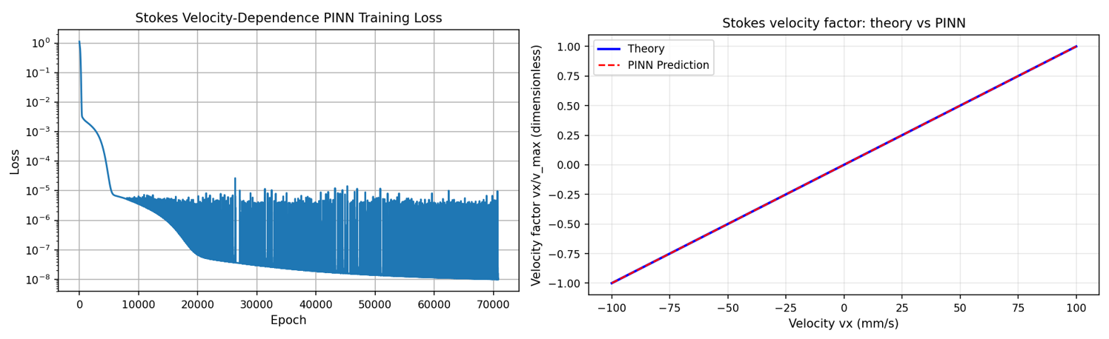
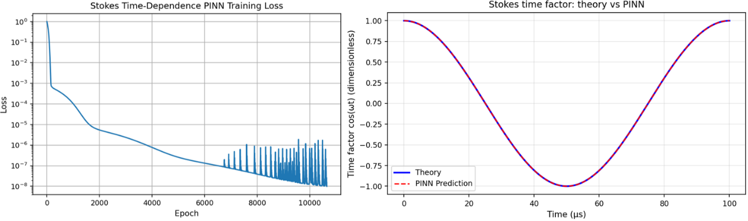
Figure 6. Residual loss over epochs during training and corresponding prediction by FF-PINN models compared with theoretical results for $F_{SPG}(x), F_{SPG}(t), F_{D}(x), F_{D}(v) and F_{D}(t)$, respectively. Each training reached targeted losses within minutes. The predictions made by FF-PINN model are all highly align with theoretical results.

Results and discussions

3.1 Particle distribution
To evaluate the reliability of FF-PINN in predicting particle transport within acoustic field, the relative change in particle number concentration (PNC) was compared against traditional DEM simulations and FEM results.
In these simulations, particles are initialized with a uniform distribution and subjected to both SPGF and Stokes drag force. The frequency is fixed at 10 kHz with a time step of 1×10⁻⁶ s. Results predicted by FEM are treated as the baseline due to the high accuracy of the FEM in handling complex boundary conditions that dictate the reliability of theoretical acoustic field calculations. As illustrated in Fig 7, the spatial distributions of relative particle concentration change predicted by the FF-PINN, DEM and FEM models exhibit considerable agreement. Fig 7(a) and 7(b) collectively demonstrate that the three models capture the fundamental spatial pattern of particle aggregation, characterized by distinct peaks in relative concentrations. Specifically, these peaks are consistently located near positions of x = 8.5 mm and x = 25.5 mm, which correspond to the antinodes of the standing acoustic wave. This indicates that particles are primarily driven by the combined SPGF and Stokes drag to migrate towards these regions of maximum acoustic velocity amplitude. Once near an antinode, the acoustic pressure gradient diminishes significantly, leading to a reduction in the effective driving force and consequently causing particles to accumulate there. The alignment in the shape and peak locations of the concentration plots from FF-PINN, DEM and FEM provides strong evidence for the validity of the FF-PINN approach in modeling the dominant physical mechanisms of AA.
A detailed examination of the normalized error between FF-PINN and FEM predictions is presented in Fig 7(c), which offers quantitative insight into their performances. The error remains below 6% for all evaluated time instances, confirming the overall accuracy of the FF-PINN model. However, a systematic deviation is observed where the error magnitude increases notably in the vicinity of the antinodes, precisely where particle concentration is highest. This localized discrepancy can be attributed to the current FF-PINN formulation, which incorporates a simplified physical model. Specifically, it does not account for secondary inter-particle effects such as the acoustic wake effect and mutual radiation pressure effect [28], which may become more pronounced in high-concentration regions. Furthermore, the FEM model utilizes a flow field description refined with an Oseen correction to the basic Stokes drag model. This more detailed treatment likely contributes to its systematically higher concentration predictions near aggregation zones compared to the FF-PINN results. Nevertheless, the fundamental agreement in the spatial aggregation pattern and the containment of absolute error within a small margin substantiate that the FF-PINN model reliably captures the key dynamics of particle transport and aggregation under the influence of the primary acoustic and fluid forces with high efficiency.
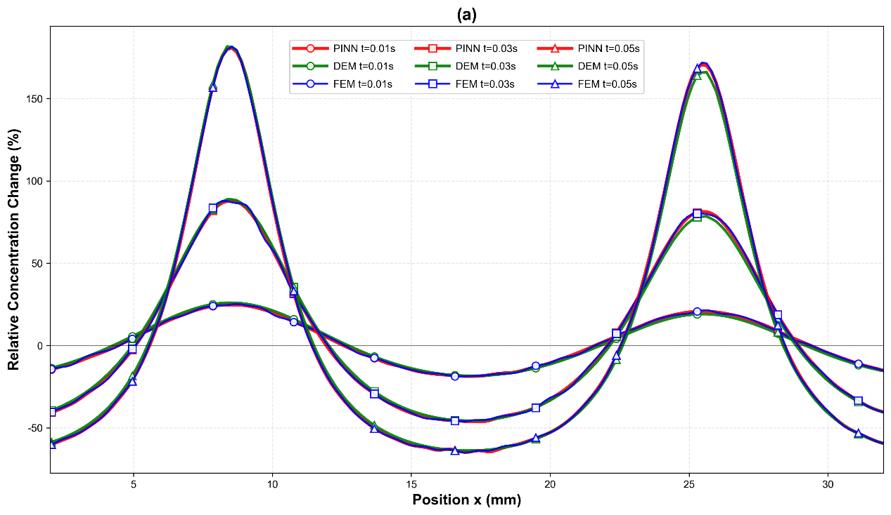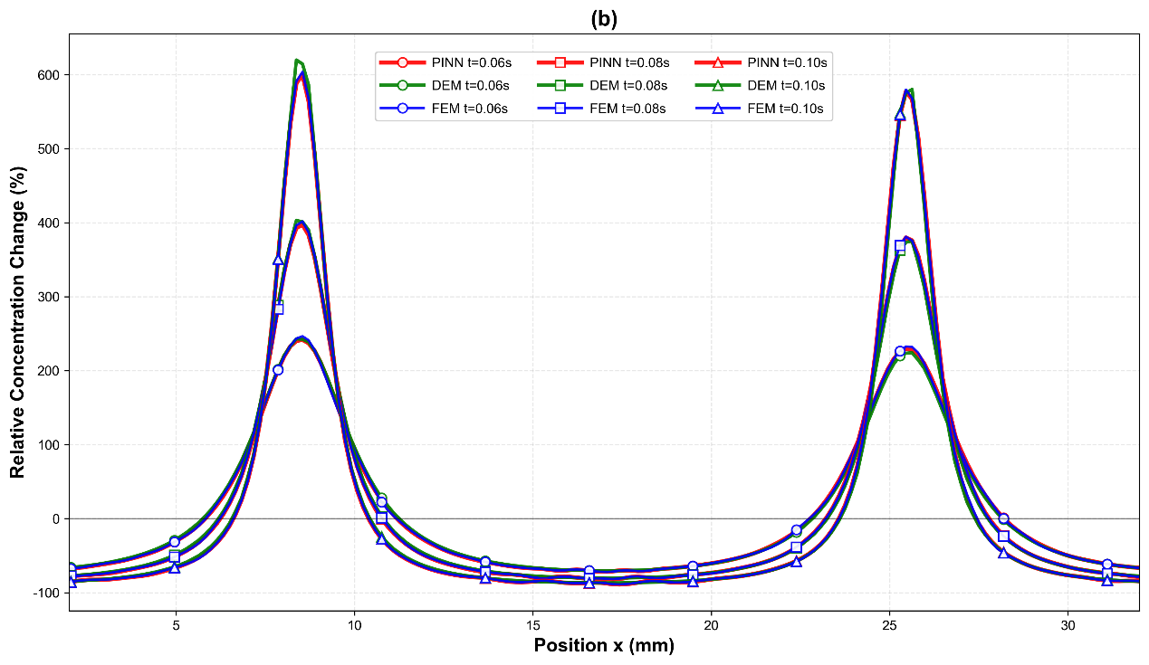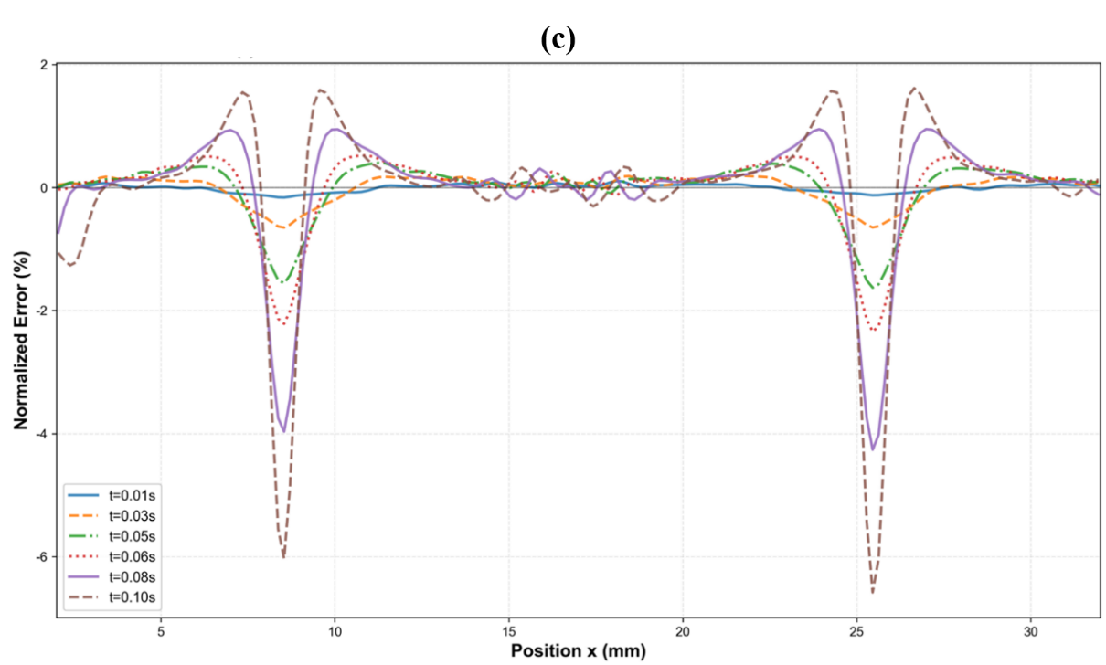
Figure 7. Particle concentration under excitation of acoustic field based on different methods of prediction: DEM, FEM and FF-PINN. Particles shift towards the nodal positions of the sound wave and gradually accumulate there. (a) shows the concentration at time t=0.01s, 0.03s and 0.05s, while (b) shows concentration at t=0.06s, 0.08s and 0.1s. (c) shows the overall deviation of the predictions by FF-PINN, taking the FEM simulation as a baseline.

3.1.1 Temporal evolution of particle distribution
The temporal evolution of the particle number concentration, as depicted in the results, elucidates a distinct acceleration in the aggregation rate over time. This is a direct consequence of the particle dynamics that is governed by the initial conditions and associated forces. Initially, the particles are distributed uniformly and with zero velocity. As the acoustics field is turned on, particles begin to migrate toward the acoustic antinodes (at approximately $8.5 mm$ and $25.5 mm$) under the sustained influence of the SPGF and Stokes drag. This initial phase is characterized by a relatively modest increase in local concentration as the particles must overcome inertia from a stationary state.
However, as the simulation progresses from 0.01 s to 0.10 s, the particles accumulate momentum from the constant acoustic forcing field. This acquired velocity, combined with their inherent inertia, leads to a progressive increase in migration speed of particles toward the aggregation zones. Consequently, the rate at which particles converge upon the antinodes is not constant but increases significantly with time. This is clearly evidenced by the non-linear growth of the relative concentration change peaks, whereby the increase between 0.05 s and 0.08 s is substantially greater than that between 0.01 s and 0.03 s.
The aggregation process thus exhibits a clear accelerating trend, where the later stages of the simulation see a much more rapid accumulation of particles at the fixed antinode positions than the earlier stages. This accelerating behavior, fundamentally linked to the transition from rest to directed motion under constant forcing, underscores the dynamic nature of the AA process where temporal history and inertial effects play a critical role in determining the final aggregation efficiency.

3.1.2 Frequency sweep
To further clarify the frequency-dependent characteristics of particle transport, Fig 8 plots the average particle displacement per cycle against frequency on a logarithmic scale for SPLs ranging from 120 dB to 160 dB, which reveals two primary trends that govern AA dynamics. Firstly, the displacement magnitude increases substantially with higher SPL, with the curve for 160 dB showing values that are orders of magnitude greater than that for 120 dB across the frequency spectrum, emphasizing the dominant role of acoustic intensity in driving particle motion. Secondly, for any given SPL, displacement consistently decreases as frequency rises from 8 to 22 kHz, reflecting a reduction in the effectiveness of the acoustic forcing at higher frequencies.
A critical observation is the variation in the slope of this decline with SPL; the decrease is more pronounced at lower SPL levels, as indicated by the steeper negative slopes of the curves for120 dB and 130 dB compared to the relatively gentler slopes for 150 dB and 160 dB. This behavior is attributed to the balance between the acoustic driving force and particle inertial response. At high SPLs, the strong acoustic force can partially compensate for the diminished particle responsiveness at elevated frequencies, thereby sustaining measurable displacement even when the frequency is non optimal. Conversely, at lower SPLs, the weaker acoustic force is insufficient to overcome the rapid decline in particle response with increasing frequency, leading to a more severe reduction in displacement. The high coefficients of determination for each SPL curve further validate the consistency of these relationships, confirming the systematic influence of both frequency and SPL on AA efficiency.
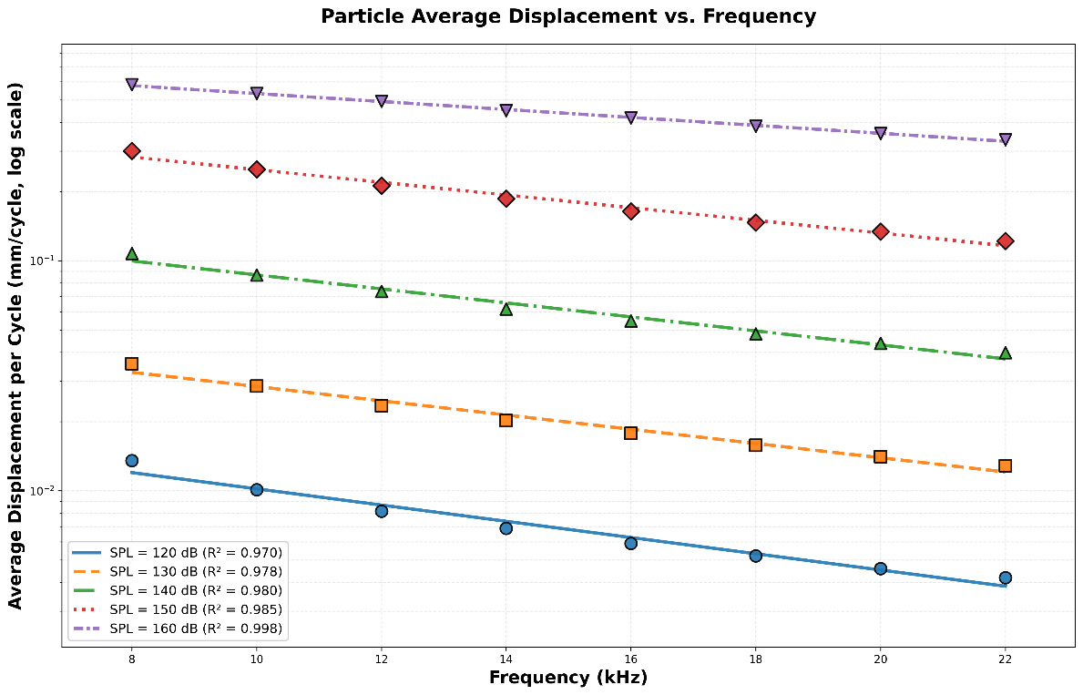
Figure 8. Particle average displacement under different frequencies and SPLs. As SPL increases, the particle average displacement increases. On the other hand, as frequency increases, the particle average displacement drops.
The spatial distributions of particle number density at different acoustic frequencies reveal the role of frequency in governing agglomeration dynamics. Fig 9(a) relative concentration variation after 100 acoustic cycles, while Fig 9(b) corresponds to 1000 cycles. In both cases, particle concentration exhibits periodic maxima and minima, indicating the formation of preferential accumulation zones. As the excitation frequency increases from $8 kHz$ to $16 kHz$, the positions of the concentration peaks shift and the number of accumulation sites within the same spatial domain increases. This reflects the fact that higher frequencies generate shorter acoustic wavelengths and therefore more pressure nodes, reducing the distance particles must travel to reach trapping locations and creating a denser spatial pattern of aggregation sites. Comparison between the 100-cycle and 1000-cycle cases demonstrates the cumulative effect of sustained excitation. After 100 cycles, particle migration toward the nodes is still in progress, whereas after $1000$ cycles, the peaks become sharper and the troughs deeper, showing enhanced particle focusing and segregation. Despite this increased structural clarity, the intensity of aggregation decreases with increasing frequency. At lower frequencies, slower oscillatory forcing allows particles to respond more effectively, leading to higher concentration amplitudes. In contrast, at higher frequencies, rapid oscillations limit particle adaptation, weakening net migration even though more trapping sites are present. These results highlight a trade-off between the spatial resolution of aggregation sites and the effectiveness of particle transport, emphasizing the need to consider both the acoustic field structure and particle response when selecting the optimal operating frequency.
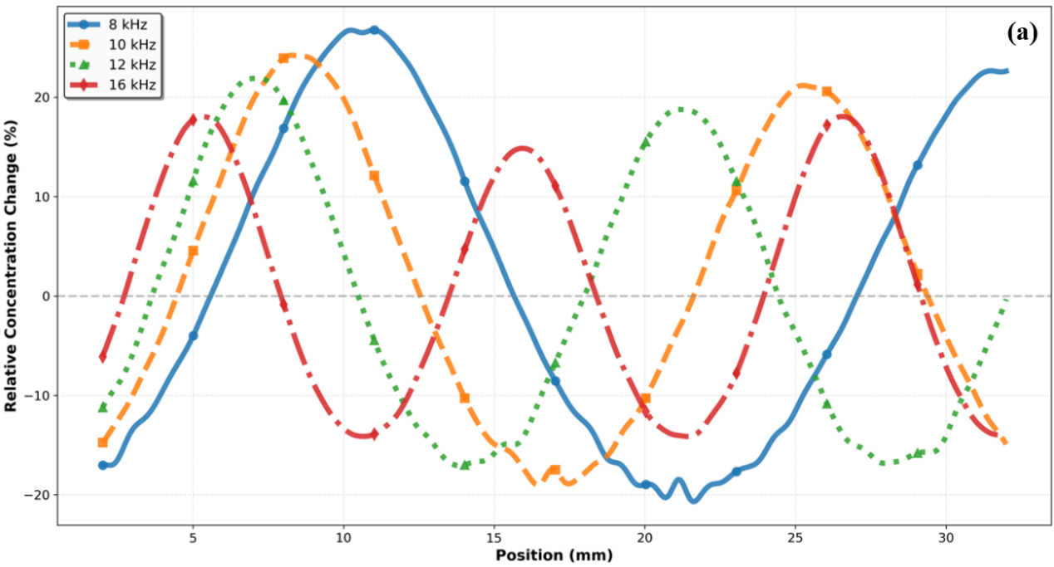
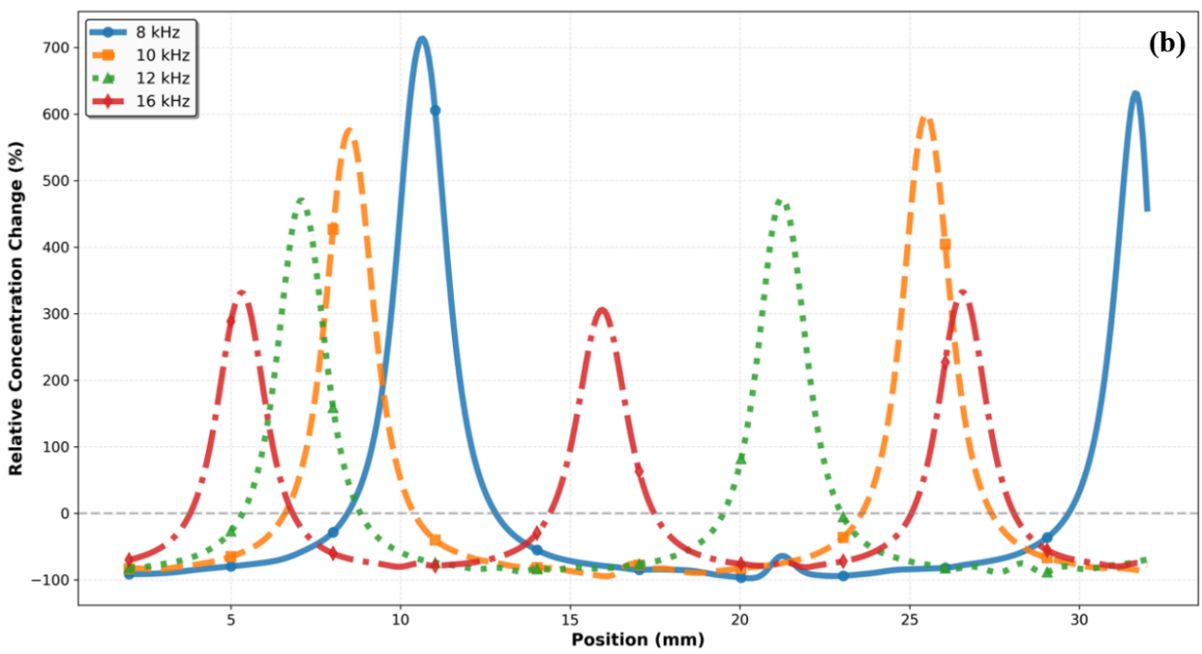
Figure 9. Particle concentration under acoustic excitation with consistent SPL=168.5 dB but different frequencies after (a) 100 cycles. (b) 1000 cycles.

3.1.3 Density sweep
To further clarify the influence of particle inertia on aggregation dynamics under a fixed acoustic field, the effects of particle material density is investigated. Fig 10 analyzes the spatial distribution and peak concentration of particles after a constant simulation duration of 10,000 time steps, with frequency and SPL held constant. The diagram presents the spatial distribution of relative concentration change for particles with densities ranging from 1000 to 5000 kg/m³. A clear trend is observed where the peak magnitude of the concentration profile systematically decreases as particle density increases. Denser particles possess higher inertia, which renders them less responsive to the fixed SPGF. Also, the Stokes drag from the surrounding fluid is insufficient to effectively entrain these heavier particles to the acoustic oscillations, thereby reducing their net migration velocity and resulting in weaker aggregation at the antinodes.
Furthermore, at the highest densities of 4000 and 5000 kg/m³, a subtle local depression or flattening emerges at the center of the primary concentration peak. This feature indicates that within the immediate vicinity of the antinode, where the acoustic pressure gradient approaches zero, the already weak effective force on these high-inertia particles is insufficient to organize them into a single, sharp density maximum. These results underscore that the acoustic intensity remains as the decisive factor governing AA.
The reduced aggregation efficiency observed at higher particle material densities can be attributed to the increase in particle inertia, while the effective surface area associated with the Stokes drag force remains unchanged. Consequently, achieving comparable particle migration and aggregation for higher-density particles requires a stronger acoustic field, which provides sufficient SPGF to overcome the increased inertia and enhances fluid–particle coupling through Stokes drag for effective transport. This dependency further validates the paramount role of SPL in enabling and controlling the agglomeration process.
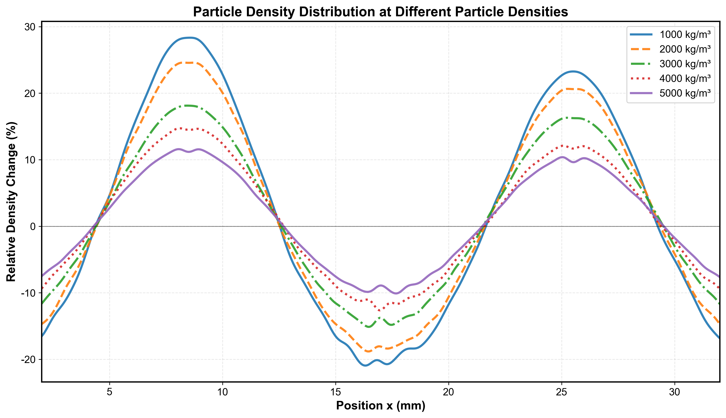
Figure 10. Particle accumulation under acoustic excitation predicted by FF-PINN for different particle densities. Smaller particle density exhibits higher concentrations at the nodes.

3.2 Computation time consumption
The time consumption by DEM and FF-PINN to conduct simulation is compared. The timestep is again fixed at Δt = 1 × 10⁻⁶ s and the number of steps is fixed at 40,000 to target at a residence time of 0.04 s. The number of particles variates from 10,000 to 100,000, with an increment of 10,000 during testing. The results of time consumption are shown in Fig 11. The computational efficiency comparison among FEM, DEM and FF-PINN models reveals a significant performance advantage of the FF-PINN approach, which utilized approximately 23.8% of the computational time compared to DEM for one million particles and only 4% that of FEM at 100,000 particles.
This substantial speedup stems from fundamental differences in how forces are computed within each time step. The DEM method relies on explicit physical formula evaluation for every particle at each iteration. It calculates SPGF through pressure gradient computations involving trigonometric functions, computes pressure differences between front and back particle points using analytical formulae and simultaneously evaluates Stokes drag forces by computing acoustic air velocity fields through additional trigonometric operations and applying relative velocity calculations. These computational steps require repeated evaluation of complex mathematical expressions including wave number calculations, phase-dependent sinusoidal terms and force magnitude computations, resulting in computational complexity that scales linearly with particle count but with high per-particle overheads.
In contrast, the FF-PINN approach leverages pre-trained and integrated NN models that have already learned the underlying physical relationships between particle states and resulting forces during an offline training phase. During runtime, the FF-PINN method performs force prediction through highly optimized NN forward and backward propagation operations. This includes input normalization that transforms particle positions, velocities and time into normalized feature spaces using linear operations for ease of calculation through unified scaling. The normalized inputs are then passed through trained NN layers, which are composed of matrix multiplications and activation functions that are computationally efficient from parallel batch processing. The outputs are subsequently denormalized to physical force values.
NN inference operations, particularly matrix multiplications, are highly parallelizable and can benefit from optimized tensor operations in frameworks like PyTorch. As a result, the FF-PINN method can process all particles simultaneously in batches using matrices and arrays rather than requiring per-particle sequential computations. Moreover, the pre-trained networks have effectively encoded complex physical relationships such as wave propagation, SPGF and Stokes drag interactions into their learned weights. This eliminates the need for real-time evaluation of trigonometric functions, pressure gradient calculations and other computationally expensive analytical expressions that the DEM approach must compute repeatedly. This architectural difference means that while both methods exhibit linear scaling with particle count, FF-PINN approach maintains a much lower computational consumption per particle due to the efficiency of batch-parallel NN operations versus sequential physical formula evaluations. This explains the observed performance improvement that becomes increasingly pronounced as particle numbers grow.
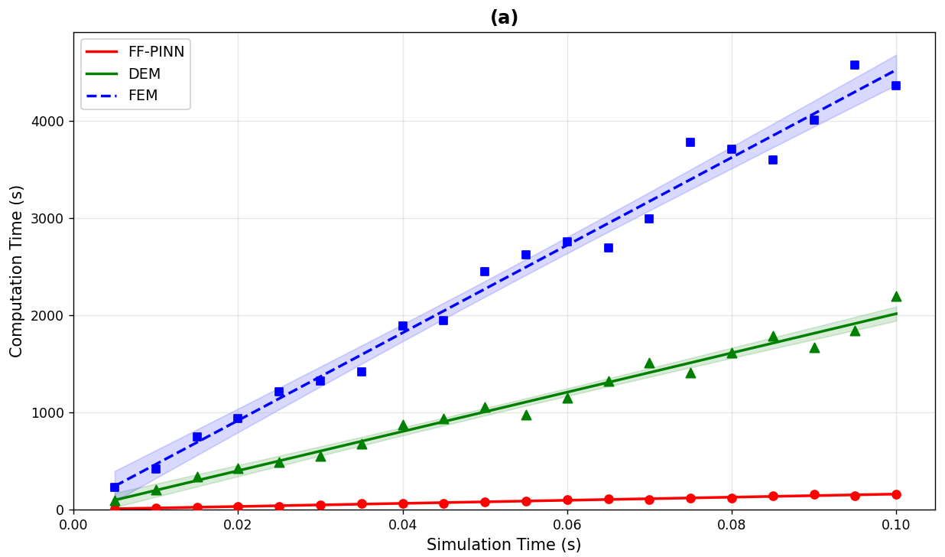
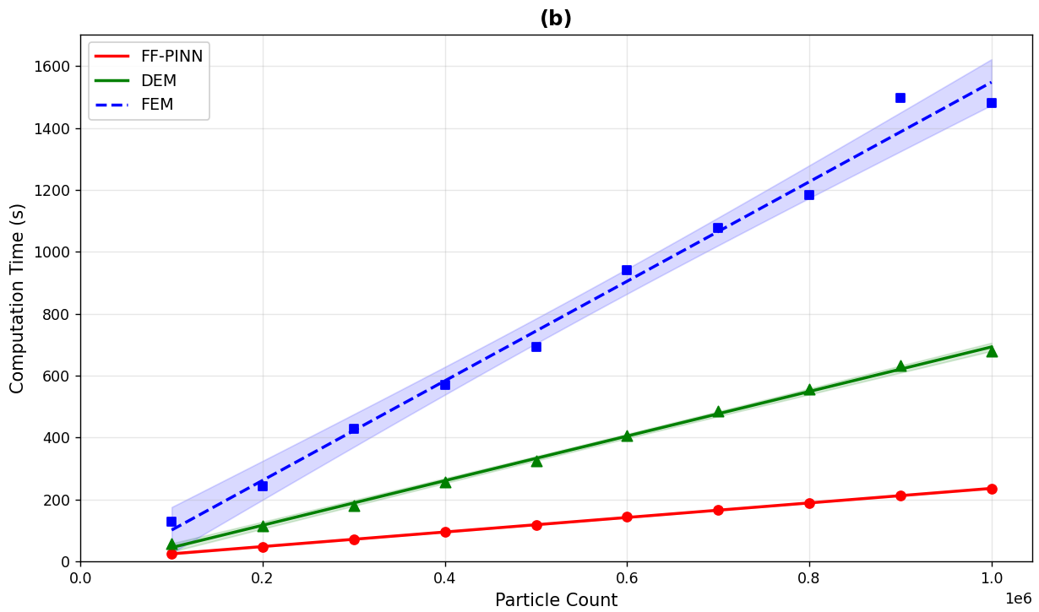
Figure 11. Computational time consumption by FF-PINN (red), DEM (green) and FEM (blue) for (a) different simulation time and (b) different number of particles involved.

3.3 Orthokinetic interaction kernel
The orthokinetic collision kernel analysis elucidates the frequency-dependent characteristics of particle interactions under a combined acoustic and flow field. In the orthokinetic interaction framework, the agglomeration kernel quantifies the volumetric collision rate between two particles of diameters $d_{1}$ and $d_{2}$ at time $t$. It is expressed as [29]
$$\begin{aligned}K\left(d_{1},d_{2},t\right)=\frac{π}{4}{\left(d_{1}+d_{2}\right)}^{2} ⋅∣Δv\left(t\right)∣⋅P_{coll}\left(∣Δv\left(t\right)∣\right)\#\left(20\right)\end{aligned}$$ The first factor $\frac{π}{4}{\left(d_{1}+d_{2}\right)}^{2}$ is the geometric collision cross-section, representing the effective area within which two approaching particles will come into contact [28]. The second factor |Δv(t)| is the ensemble-averaged relative velocity between particle pairs at time $t$. The third factor $P_{coll}$ is the collision adhesion probability. The relative velocity |Δv(t)| is the term directly supplied by the FF-PINN model.
At each simulation time step, the trained FF-PINN predicts the net force acting on every particle through its unified physical formulation, which couples the acoustic radiation force and the frequency-dependent Stokes drag within a single network. These predicted forces advance the particle velocities forward in time through explicit Euler integration. The relative velocity is then computed as the mean of ||v_{i} (t) - v_{j} (t)|| over an ensemble of randomly sampled particle pairs. Through this mechanism, the FF-PINN imprints its learned acoustic dynamics directly onto the collision kernel, so that all frequency-dependent and time-resolved features of the flow field are propagated into the final agglomeration rate. The collision adhesion probability is modelled empirically as
$$\begin{aligned}P_{coll}\left(Δv\right)=1-\exp\left(-\frac{∣Δv∣}{v_{s}}\right) \#\left(21\right)\end{aligned}$$

where v_{s}=0.02 m/s is a characteristic velocity scale. This term ensures that the collision probability remains within [0, 1], exhibits proportionality with relative velocity at low speeds and saturates to unity as relative velocity increases.
Fig. 12(a) presents the temporal evolution of the mean collision kernel over one acoustic period for excitation frequencies from 8 kHz to 16 kHz. The kernel reaches its local maxima at the nodal instants of the standing wave. At these moments, the instantaneous sound pressure passes through zero. The local Stokes drag force becomes maximum and particles experience the greatest net acceleration. The resulting peak in relative velocity therefore leads to a corresponding peak in the collision kernel. As excitation frequency increases, two systematic trends emerge.
Firstly, the peak kernel magnitude decreases progressively. At higher frequencies the acoustic period shortens, and particles whose relaxation time is not negligibly small relative to the period cannot fully follow the rapid oscillations. Their translational response is suppressed, relative velocity is reduced, and the collision probability falls accordingly. Next, the temporal profile of the kernel shifts toward earlier times within the period. Higher frequencies compress the characteristic timescale of particle response, so that the maximum collision probability is reached sooner within each cycle.
Fig. 12(b) shows the spatial distribution of the collision kernel as a function of particle diameter pair at 8 kHz and 16 kHz. The overall kernel magnitude is substantially higher at 8 kHz than at 16 kHz, consistent with the temporal results and confirming that lower frequencies promote more effective dynamic coupling between particles and the oscillatory flow. In both cases, the kernel increases markedly with increasing size disparity between the two colliding particles. Particles of unequal diameter possess different inertial relaxation times and therefore develop stronger differential motion in response to the same acoustic forcing, which amplifies relative velocity and raises the collision probability. Taken together, these results show that both excitation frequency and particle size contrast govern the efficiency of AA, with lower frequencies and larger diameter differences promoting higher collision kernels through enhanced relative particle dynamics [14].
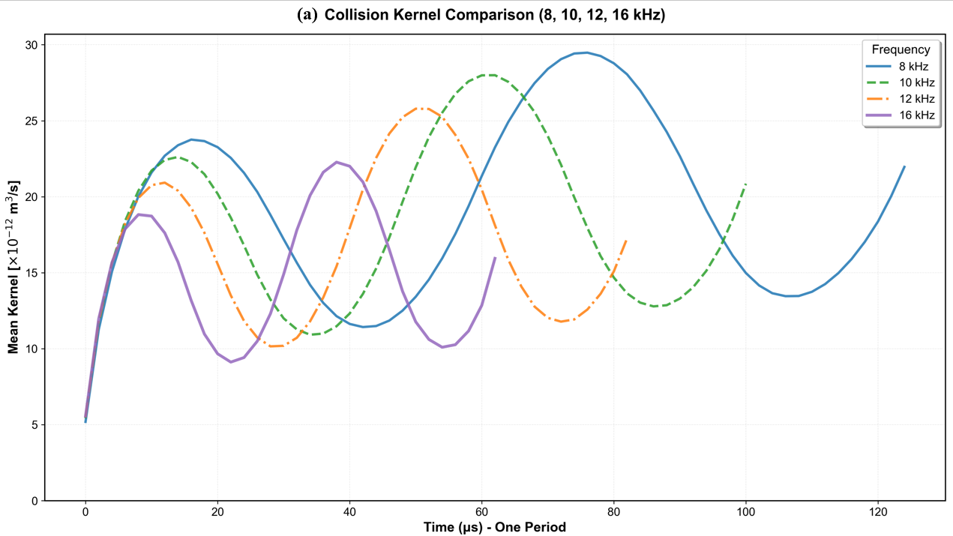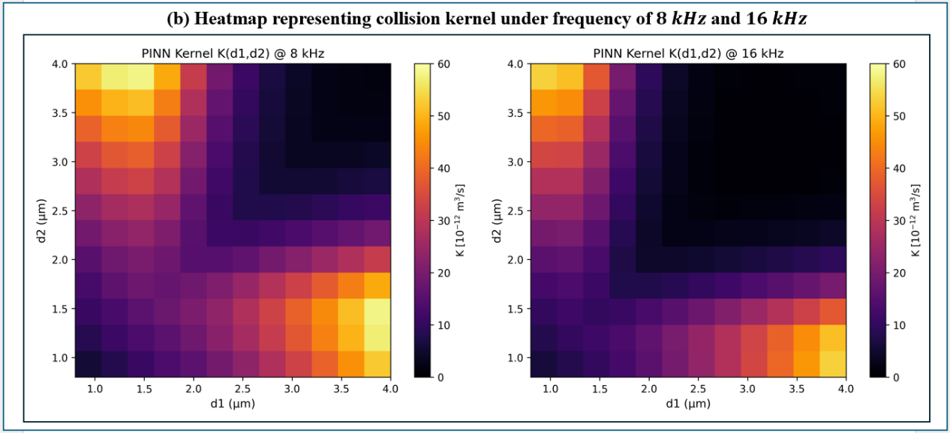
Figure 12. Heatmap representing variation of collision kernels with respect to different (a) time within a cycle under different excitation frequency and (b) combinations of sizes for two particles involved in a collision.

Conclusion
In this work, a Fourier-featured physics-informed neural network framework was developed to accelerate particle-resolved AA simulations by replacing the repeated evaluation of sound pressure gradient force and Stokes drag. By decomposing the acoustic forcing into spatial, temporal and velocity-dependent components, the proposed FF-PINN preserves the governing physics while significantly simplifying the learning task. The introduction of Fourier feature encoding further enables accurate representation of the periodic acoustic field and ensures stable convergence within a short training time.
The proposed model was comprehensively validated against FEM and DEM benchmarks. The predicted particle concentration distributions, transport trajectories and collision behaviors showed strong agreement with the reference solutions, with concentration errors remaining below 6% with component-wise prediction errors below 0.01%. These results confirm that the FF-PINN accurately captures the dominant particle dynamics governed by acoustic forcing and viscous drag. The study achieved substantial improvement in computational efficiency. Compared with FEM, the proposed FF-PINN achieves significant speedup for simulations involving massive particles and timesteps. This efficiency gain makes large-scale and long-duration particle simulations computationally practical, especially for parametric studies involving large particle populations and wide acoustic operating ranges.
Leveraging this accelerated framework, systematic investigations were carried out on the effects of SPL, excitation frequency, particle density and particle size disparity. The results reveal that stronger acoustic intensity enhances particle migration and collision probability, while increasing frequency and particle density suppress transport due to inertial limitations. In addition, lower excitation frequencies and larger particle size differences were found to promote orthokinetic collision kernels through stronger differential motion. These findings provide important physical insights into the coupled roles of acoustic forcing and particle inertia in AA. Overall, the proposed FF-PINN framework offers an accurate, efficient and scalable tool for predicting particle transport and interaction statistics in acoustic fields. It establishes a strong foundation for future integration of more complex mechanisms, including acoustic wake effects and mutual radiation pressure interactions, toward high-fidelity large-scale AA simulations.

CRediT authorship contribution statement
Hang Yin: Conceptualization, Methodology, Simulation, Data curation, Formal analysis, Writing - original draft. Pengzhan Liu: Writing – review & editing. Bing Feng Ng: Conceptualization, Supervision, Funding acquisition, Writing - review & editing.

Declaration of competing interest
The authors declare that they have no known competing financial interests or personal relationships that could have appeared to influence the work reported in this paper.

Acknowledgments
This research is supported by the National Research Foundation, Singapore and the Energy Market Authority, under its Energy Programme (EP Award EMA-EP009-SEGC-007). The authors would also like to acknowledge the support by MOE Tier 2 (MOE-T2EP50123-0003). Any opinions, findings and conclusions or recommendations expressed in this material are those of the author(s) and do not reflect the views of National Research Foundation, Singapore and the Energy Market Authority.

References
[1] R. Sharma, O. P. Kurmi, P. Hariprasad, and S. K. Tyagi, “Health implications due to exposure to fine and ultra-fine particulate matters: a short review,” Int. J. Ambient Energy, vol. 45, no. 1, Dec. 2024, doi: 10.1080/01430750.2024.2314256.
[2] G. Zhang, Z. Ma, J. Shen, K. Zhang, J. Wang, and Z. Chi, “Experimental study on eliminating fire smokes using acoustic agglomeration technology,” J. Hazard. Mater., vol. 382, p. 121089, 2020, doi: 10.1016/j.jhazmat.2019.121089.
[3] G. Liu et al., “Enhanced particulate matter removal from flue gas of organic solid waste through acoustic agglomeration,” Sep. Purif. Technol., vol. 360, p. 131244, 2025, doi: 10.1016/j.seppur.2024.131244.
[4] E. R.-F. de Sarabia et al., “Acoustic agglomeration of submicron particles in diesel exhausts: First results of the influence of humidity at two acoustic frequencies,” J. Aerosol Sci., vol. 31, pp. 827–828, 2000.
[5] B. F. Ng, J. W. Xiong, and M. P. Wan, “Application of acoustic agglomeration to enhance air filtration efficiency in air-conditioning and mechanical ventilation (ACMV) systems,” Plos One, vol. 12, no. 6, p. e0178851, 2017, doi: 10.1371/journal.pone.0178851.
[6] G. Shen, X. Huang, C. He, S. Zhang, and L. An, “Experimental study of acoustic agglomeration and fragmentation on coal-fired ash with different particle size distribution,” Powder Technol., vol. 325, pp. 145–150, 2018, doi: 10.1016/j.powtec.2017.10.037.
[7] K. Donaldson, V. Stone, A. Clouter, L. Renwick, and W. MacNee, “Ultrafine particles,” Occup. Environ. Med., vol. 58, no. 3, pp. 211–216, 2001, doi: 10.1136/oem.58.3.211.
[8] A. Hancock, “Observation of forces on microparticles in acoustic standing waves,” PhD Thesis, University of California, Davis, 2001. Accessed: May 23, 2025. [Online]. Available: https://ultrasonics.bioengineering.illinois.edu/pdfs/Thesisah.pdf
[9] J. Cleckler, S. Elghobashi, and F. Liu, “On the motion of inertial particles by sound waves,” Phys. Fluids, vol. 24, no. 3, 2012, doi: 10.1063/1.3696243.
[10] F. Fan, X. Yang, and C. N. Kim, “Direct simulation of inhalable particle motion and collision in a standing wave field,” J. Mech. Sci. Technol., vol. 27, no. 6, pp. 1707–1712, Jun. 2013, doi: 10.1007/s12206-013-0420-4.
[11] P. Liu et al., “Ultrasonic aerosol agglomeration: Manipulation of particle deposition and its impact on air filter pressure drop,” Ultrason. Sonochem., vol. 103, p. 106774, 2024, doi: 10.1016/j.ultsonch.2024.106774.
[12] X. Zhang et al., “An efficient strategy to enhance air filtration through the synergistic effects of ultrasonics and seed particles,” Sep. Purif. Technol., vol. 353, p. 128600, 2025, doi: 10.1016/j.seppur.2024.128600.
[13] A. A. Doinikov, “Acoustic radiation pressure on a compressible sphere in a viscous fluid,” J. Fluid Mech., vol. 267, pp. 1–22, 1994, doi: https://doi.org/10.1017/S0022112094001096.
[14] S. Dong, B. Lipkens, and T. M. Cameron, “The effects of orthokinetic collision, acoustic wake, and gravity on acoustic agglomeration of polydisperse aerosols,” J. Aerosol Sci., vol. 37, no. 4, pp. 540–553, 2006, doi: 10.1016/j.jaerosci.2005.05.008.
[15] D. T. Shaw and K. W. Tu, “Acoustic particle agglomeration due to hydrodynamic interaction between monodisperse aerosols,” J. Aerosol Sci., vol. 10, no. 3, pp. 317–328, 1979, doi: 10.1016/0021-8502(79)90047-8.
[16] J. Liu, G. Zhang, J. Zhou, J. Wang, W. Zhao, and K. Cen, “Experimental study of acoustic agglomeration of coal-fired fly ash particles at low frequencies,” Powder Technol., vol. 193, no. 1, pp. 20–25, 2009, doi: 10.1016/j.powtec.2009.02.002.
[17] P. Liu et al., “Reshaping particle entrainment dynamics in single-source airborne sound fields,” Powder Technol., vol. 470, p. 122015, Mar. 2026, doi: 10.1016/j.powtec.2025.122015.
[18] D. Zhou et al., “Preliminary experimental study of acoustic agglomeration of coal-fired fine particles,” Procedia Eng., vol. 102, pp. 1261–1270, 2015, doi: 10.1016/j.proeng.2015.01.256.
[19] P. Liu et al., “Rapid and versatile numerical simulations of acoustic agglomeration by the fixed pivot-based population balance modeling,” Powder Technol., vol. 456, p. 120821, 2025, doi: 10.1016/j.powtec.2025.120821.
[20] C. Sheng and X. Shen, “Simulation of Acoustic Agglomeration Processes of Poly-Disperse Solid Particles,” Aerosol Sci. Technol., vol. 41, no. 1, pp. 1–13, Feb. 2007, doi: 10.1080/02786820601009704.
[21] H. Bruus, “Acoustofluidics 7: The acoustic radiation force on small particles,” Lab. Chip, vol. 12, no. 6, pp. 1014–1021, 2012, doi: 10.1039/C2LC21068A.
[22] D. Markauskas, R. Kačianauskas, and A. Maknickas, “Numerical particle-based analysis of the effects responsible for acoustic particle agglomeration,” Adv. Powder Technol., vol. 26, no. 3, pp. 698–704, 2015, doi: 10.1016/j.apt.2014.12.008.
[23] A. Maknickas, D. Markauskas, and R. Kačianauskas, “Discrete element simulating the hydrodynamic effects in acoustic agglomeration of micron-sized particles,” Part. Sci. Technol., vol. 34, no. 4, pp. 453–460, Jul. 2016, doi: 10.1080/02726351.2016.1156793.
[24] A. Manoylov, B. Lebon, G. Djambazov, and K. Pericleous, “Coupling of Acoustic Cavitation with Dem-Based Particle Solvers for Modeling De-agglomeration of Particle Clusters in Liquid Metals,” Metall. Mater. Trans. A, vol. 48, no. 11, pp. 5616–5627, Nov. 2017, doi: 10.1007/s11661-017-4321-5.
[25] A. G. Prinn, “A Review of Finite Element Methods for Room Acoustics,” Acoustics, vol. 5, no. 2, pp. 367–395, Apr. 2023, doi: 10.3390/acoustics5020022.
[26] L. L. Thompson, “A review of finite-element methods for time-harmonic acoustics,” J. Acoust. Soc. Am., vol. 119, no. 3, pp. 1315–1330. 2006, doi: 10.1121/1.2164987.
[27] Z. Chen, Z. Yang, Y. Zhang, C. Liu, Z. Yang, and S.-K. Lai, “A novel Fourier time-sequential PINN approach for multi-frequency analysis of nonlinear aerothermoelastic problems,” Adv. Eng. Inform., vol. 72, p. 104446, May 2026, doi: 10.1016/j.aei.2026.104446.
[28] C. Sheng and X. Shen, “Modelling of acoustic agglomeration processes using the direct simulation Monte Carlo method,” J. Aerosol Sci., vol. 37, no. 1, pp. 16–36, 2006, doi: 10.1016/j.jaerosci.2005.03.004.
[29] M. von Smoluchowski, “Drei vortrage uber diffusion, brownsche molekularbewegung und koagulation von kolloidteilchen,” Z Phys., vol. 17, pp. 585–599, 1916.

